Steps 1: Teach students what to say when they don’t know what to say. | “Can I ask a friend for help?” or “Where can I find more information?”
Step2: Have students speak in complete sentences. | My approach to solving the equation would be to…  I solved it by…
Step 3: Randomize and rotate when calling on students. | Numbered desks, popsicle sticks, Numbered Heads Together, name generator APP
Step 4: Use total response signals. | Show me a thumbs up when you are ready to share.
Step 5: Use visuals and vocabulary strategies that support your objectives. | Graphic organizers, Marzano’s Six Step Process, or Interactive Word Walls
Step 6: Have students participate in structured conversations. | - teacher poses a question  - gives students a stem  - students signal when ready  - students share  - teacher assesses
Step 7: Have students participate in structured reading and writing. | Somebody Wanted But So can be used for reading and writing about fiction or nonfiction.
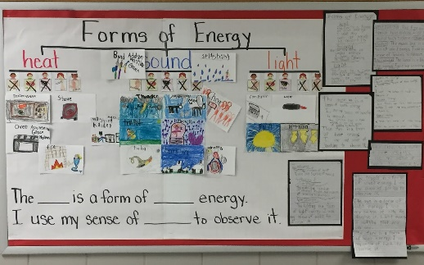 | 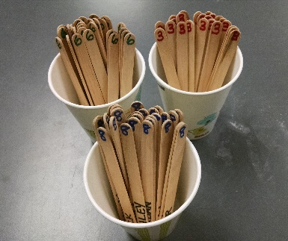
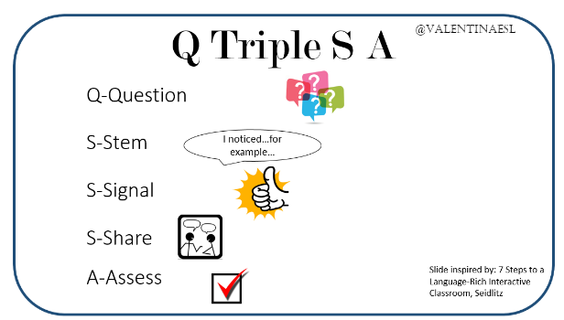 | 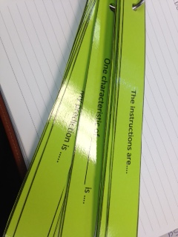
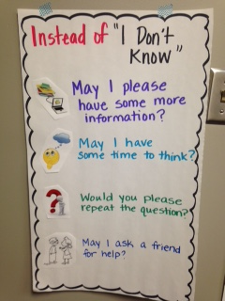
 | 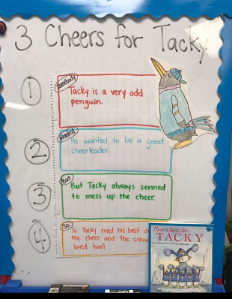
7 Steps to a Language-Rich Interactive Classroom Sort | Hand out one card to each participant. Participants review their card then search the room to find cards that correlate with theirs. Each group will end up with a STEP, description/example, and a visual representation. (3 cards total per group)

